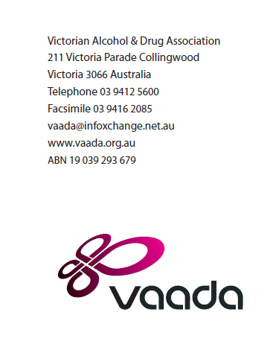

6 November 2015

What’s important to youth – discussion paper

About the Victorian Alcohol and Drug Association
The Victorian Alcohol and Drug Association (VAADA) is the peak body for alcohol and other drug (AOD) services in Victoria. We provide advocacy, leadership, information and representation on AOD issues both within and beyond the AOD sector.

As a state-wide peak organisation, VAADA has a broad constituency. Our membership and stakeholders include ‘drug specific’ organisations, consumer advocacy organisations, hospitals, community health centres, primary health organisations, disability services, religious services, general youth services, local government and others, as well as interested individuals.

VAADA’s Board is elected from the membership and comprises a range of expertise in the provision and management of alcohol and other drug services and related services.

As a peak organisation, VAADA’s purpose is to ensure that the issues for both people experiencing the harms associated with alcohol and other drug use, and the organisations that support them, are well represented in policy, program development, and public discussion.

Q. What do you think should be done to tackle alcohol and drug issues for young people?
The Victorian Alcohol and Drug Association welcomes the opportunity to contribute to this consultation. The youth AOD service system currently provides treatment services for a highly vulnerable cohort of young people, many experiencing a wide range of challenges. Bruun (2015) highlights a number of vulnerabilities evident with young people engaging AOD services, noting that:
- two thirds of young AOD service users have been involved with the justice system;
- two thirds have experienced abuse or neglect;
- 6 percent are not employed or attending school;
- 43 percent have attempted suicide or engaged in self harm;
- 19 percent experience housing instability; and
- 35 percent have a current mental health diagnosis.
Bruun (2015) cites international research highlighting a benefit of £4.66 - £8.38 for each £1 spent on youth AOD treatment.
Additional to the content from YACVic’s response to this consultation, which VAADA supports, we emphasise the importance of a youth AOD treatment system which is highly accessible to all young people. Such a system must have capacity for conducting extensive outreach activities to identify and engage with at risk and vulnerable cohorts. Aligned with the complexities evident with young AOD service users is the need for strong linkages between relevant service types. All youth services, including AOD treatment, should be provided in a flexible manner with a wide range of entry points and approaches to service provision. There is also a need to reflect on the continuum of care for young people and ensure that aftercare models are robustly resourced to ensure that young people with complex needs are adequately supported beyond the expiration of the treatment episode. Aftercare may involve engagement with a range of related service sectors.
AOD services should be delivered in an age appropriate setting and manner. This relates to not only the physical environment and mode of delivery but also the composition of those engaging the service sector. This may relate to gender specific and age specific programs and separate waiting areas.
Where appropriate, supports, including family should be involved except in cases where it may be deemed inappropriate (ie, where family violence is evident). Services should be resourced to facilitated familial involvement.
Given the wide range of vulnerabilities evident with young people engaging AOD treatment, there are opportunities through a range of interventions and preventative endeavours to reduce the harms associated with AOD use. These endeavours must be well targeted, evidence informed and well resourced. There are a number of examples of prominent prevention-based campaigns that have not been effective, such as the US based Faces of Meth campaign which elicited negative outcomes, including a threefold increase in the number of teenagers who believe that methamphetamine is not risky, and up to half of all youth believing that the ads exaggerated the risks (Society for Prevention Research 2008).
Early intervention program endeavours should also be supported with the overall aim of maximising protective factors and minimizing risk factors. Overall, it is paramount to maintain the best interests of the child in responding to AOD related issues among young people.

References
Bruun, A. 2015, The Victorian Youth alcohol and other drug service system: A vision realized, YSAS, Melbourne, Australia.
Society for Prevention Research 2008, Success of anti-meth ads questioned by study, viewed 6 November 2015, http://www.sciencedaily.com/releases/2008/12/081211081444.htm

