Victorian Youth Week 2020
Grant Guidelines

Contents
Minister’s message 3
What is Victorian Youth Week 2020? 4
What type of activities might be funded? 4
How will applications be assessed? 5
Who can apply? 6
What will not be funded? 6
What are the funding conditions? 7
What is the application process? 7
More information 8

Minister’s Message
Victorian Youth Week is an important way to celebrate the achievements of young Victorians and recognise the positive contribution they make to our state.
The Andrews Labor Government knows how critical young people are to the future of our community and our economy. When young people are involved in civic life, we all benefit.
Victorian Youth Week 2020 will give more young people a chance to plan and deliver projects, events and activities in their local area – working in partnership with their communities and creating valuable connections.
Our government recognises that when young people have their voices heard and are supported to take action on what they believe in, great things can happen.
I encourage all young Victorians to apply for a Victorian Youth Week grant – and I look forward to attending, seeing and hearing about these exciting events in action.

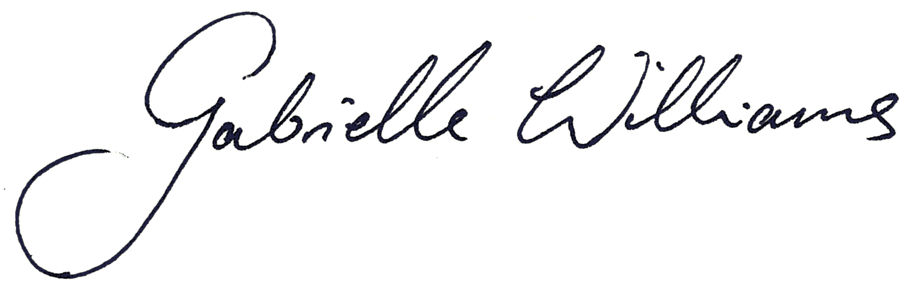

Gabrielle Williams MP
Minister for Youth

What is Victorian Youth Week 2020?
Victorian Youth Week is a week-long celebration across Victoria which recognises the contribution and achievements of young people, aged 12 to 25.
Victorian Youth Week will be held from 3 April to 12 April 2020.
The Victorian Government is providing Victorian Youth Week grants to fund events that celebrate and recognise the contribution of young people to their community.
The objectives of Victorian Youth Week grants are to:
- support young people’s participation in the planning and delivery of Victorian Youth Week activities
- promote positive images of young people by showcasing their talents, achievements and contribution to the community
- assist young people to express their ideas and provide opportunities to have their voices heard within the community.
Victorian Youth Week events are inclusive and accessible to all young people and support those who face additional barriers to community participation. Events that engage priority groups of young people such as new arrivals, refugees and asylum seekers, regional and rural Victorians, young people who identify as LGBTIQ, or those facing social isolation and disadvantage are strongly encouraged to apply.

What type of activities might be funded?
Eligible organisations can apply for grants of up to $2,000.
The Victorian Youth Week 2020 program will support youth-led activities, events and projects which focus on issues of interest to young people.
Examples of previously funded projects include:
- arts focused events, photography exhibitions, mural creations and film competitions
- cultural days and community festivals with live bands, stalls and activities
- sporting events, such as soccer tournaments, skate, BMX and basketball competitions
- workshops and forums with a focus on issues of concern to young people, including body image, equality, mental health and cultural respect.

How will applications be assessed?
Applications will be assessed against the questions detailed in the four criteria below.
Applicants must respond to each of the criteria demonstrating how the proposed project will meet the objectives of the 2020 Victorian Youth Week program.

1. Project overview
- Provide an overview of the project – identify the type of project, its goals and objectives.
- Describe the local needs for the project in the community.
- Provide evidence of the need for a project – based on data, research and consultation with young people.

2. Project delivery
- Outline how you will support young people’s participation in the planning and delivery of the project.
- Describe how you will promote positive images of young people by showcasing their talents, achievements and contributions to the community.
- Describe how you will assist young people to express their ideas and have their voices heard in developing the project.

3. Youth participation in the project
- List the key roles or activities that young people will undertake to support the successful delivery of the project.
- Outline the groups of young people who will participate in the project.
- Identify how the project will actively engage and encourage the inclusion of a diverse range of young people (including culturally and linguistically diverse, Aboriginal and Torres Strait Islander peoples, LGBTIQ₊, recently arrived refugees, young people with a disability or young people in regional and rural Victoria).

4. Project partners
- List the key partners who will support the implementation of this project (including schools, community organisations, councils and businesses).
- Describe the role that each partner will play.

Who can apply?
To be eligible, young people must be working in partnership with a local council, community organisation or school.
Commercial organisations or bodies established for profit-making purposes are not eligible to receive a Victorian Youth Week grant.

What will not be funded?
Victorian Youth Week 2020 grants will not fund:
- Projects that are not youth-focused
- Organisations that have failed to complete any previous projects funded by the Department of Premier and Cabinet, without demonstrating sufficient cause
- Activities that are the primary focus of other Victorian Government programs
- Projects that are already fully funded.
- Funding for projects that have already started or have been completed, including any activity undertaken prior to the notification of the application outcome.
- Significant funding for equipment that the project does not require for its ongoing life
- Requests for the purchase, maintenance or upgrading of facilities or equipment
- Requests for salary subsidies.
- Projects, activities or travel outside Victoria, or funding for people or organisations from overseas to visit Victoria.
- Party political activities.

What are the funding conditions?
Grants of up to $2,000 are available. Organisations applying for funding will be required to outline other contributions for the proposed project, such as financial and in-kind support.
The following conditions will apply to all projects that receive a grant.
- The grant recipient must enter into a funding agreement with the Department of Premier and Cabinet that sets out the conditions and reporting requirements.
- Any variation to the approved project must be submitted to the Department of Premier and Cabinet for approval prior to implementation.
- All projects must:
  - be accessible to young people, aged 12 to 25, in their local community
  - take place in Victoria during Victorian Youth Week from 3 April to 12 April 2020 (there may be some flexibility around this date – contact the Office for Youth for more information)
  - be alcohol, smoke and drug-free
  - provide safe and secure environments for young people
  - be covered by all appropriate insurance, including public liability insurance for not less than $5 million
- All publicity, promotional material and signage relating to the project must prominently display the Victorian Youth Week logo and the Victorian Government logo.
- All promotional material and publicity generated by the funded organisation relating to the project must include the following acknowledgement:
  - ‘This event is supported by the Victorian Government’
- Grant recipients will be required to complete a Victorian Youth Week 2020 report that includes photographs, films or mixed media artwork related to their project, event or activity.

What is the application process?
Applications (including any attachments) must be submitted using the Victorian Youth Week 2020 Application Form by 11:59pm Monday 14 October 2019. Late or incomplete applications will not be considered. Receipt of applications will be acknowledged by the application portal.
The Victorian Youth Week 2020 Grant Guidelines and Application Portal can be accessed from the Youth Central website at www.youthcentral.vic.gov.au/vyw
Applications must be submitted through the Department of Premier and Cabinet’s on-line grants portal. The application form can be access at this link: https://dpc1.force.com/publicform/vywg2020

More information
For more information, please contact 1300 366 356 or send an email to youthweek@dpc.vic.gov.au Monday to Friday between 9.00am and 5.00pm (except public holidays).

To receive this publication in an accessible format email Office for Youth youthweek@dpc.vic.gov.au
Authorised and published by the Victorian Government, 1 Treasury Place, Melbourne.
© State of Victoria, Department of Premier and Cabinet, August 2019.
Where the term ‘Aboriginal’ is used it refers to both Aboriginal and Torres Strait Islander people. Indigenous is retained when it is part of the title of a report, program or quotation.
Available at Victorian Youth Week <https://www.youthcentral.vic.gov.au/get-involved/youth-programs-and-events/victorian-youth-week>

