Funding guidelines
Empower Youth initiative

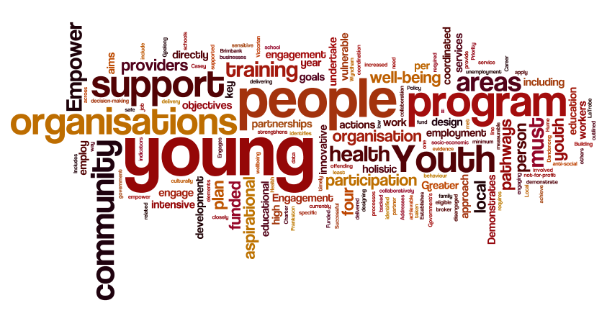

Minister’s message
Supporting young people and investing in initiatives that enhance their social, community and economic opportunities is a priority for the Andrews Labor Government.
We are taking action in a number of areas to improve opportunities and outcomes for young people through the Roadmap to Reform: strong families, safe children; the Education State; the Back to Work scheme and our response to the recommendations of the Royal Commission into Family Violence.
Through our Youth Policy: Building Stronger Youth Engagement in Victoria the Andrews Labor Government is ensuring every young person has the opportunities and support they need to reach their full potential.
Due to a range of circumstances, some young people become disconnected from family, education and community and require more intensive and tailored support to achieve their goals and enhance their life outcomes.
In the first stage of the Empower Youth program we funded eight organisations to work with vulnerable young people at risk of disengagement, to strengthen their health and well-being, their connection to community, their engagement in education and training and their pathways to employment.
These projects operate within Ballarat, Brimbank, Casey, Dandenong, Frankston, Greater Geelong, Hume, Mornington Peninsula, Morwell and Wyndham.
In stage two of the Empower Youth program, we are investing $2 million over four years (2018–2022), to fund further projects in areas of high priority.
The development, design and delivery of local Empower Youth programs will continue to directly engage young people to ensure that the program meets their goals and circumstances.
I encourage local government and community organisations, in the priority areas we are targeting, to apply for funding to deliver the second stage of this exciting program.
I look forward to seeing the innovative and engaging initiatives that are developed with young people to empower them to realise their aspirations.

Jenny Mikakos MP
Minister for Youth Affairs

What is Empower Youth?
The Empower Youth program requires funded organisations to undertake an innovative approach to designing and delivering a program that strengthens the health and well-being of young people; their participation in community; their engagement in education and training; and their pathways to employment.
Each organisation must engage young people in the development and design of the Empower Youth program. In addition, young people must be involved in the decision-making processes related to their aspirational plan and the support they receive in each of the four areas outlined below.
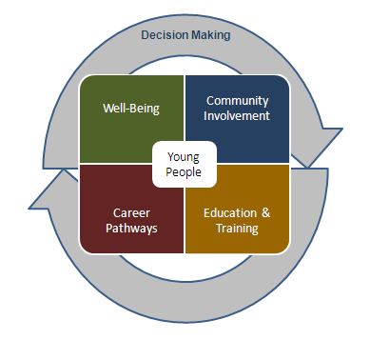
Successful organisations will be funded to engage youth workers to broker local partnerships, undertake outreach and provide intensive, coordinated support for vulnerable young people.
Organisations can employ youth workers directly, or employ one directly and fund others in a partner organisation, to support collaboration and the provision of coordinated services to young people.
Funded organisations will be required to work collaboratively with other organisations, such as:
- schools and other educational and training providers
- community and health organisations
- local government
- local businesses and job providers
  - culturally sensitive and safe service providers.
The Empower Youth program will target vulnerable young people including those disengaged from school, family and community or at risk of engaging in anti-social behaviour.
Each funded organisation must support a minimum of 50 young people per year and work closely with each young person to develop an aspirational plan which identifies the goals and the actions to be taken to support the young person in the four key areas of health and well-being, community participation, education and training, and pathways to employment. Higher levels of participation by young people will be required from larger scale programs and a minimum of 100 young people would have to be supported at the maximum level of funding available.
The program will be delivered in areas experiencing high socio-economic disadvantage, including areas of high youth unemployment, increased youth offending, low educational engagement and poor health or mental wellbeing indicators for young people.
Target areas include, but are not limited to:
- Brimbank  - Casey  - Central Goldfields  - East Gippsland  - Frankston  - Gannawarra  - Greater Bendigo  - Greater Geelong | - Greater Shepparton  - La Trobe  - Melton  - Mildura  - Swan Hill  - Whittlesea  - Wyndham
Priority will be given to areas where the Empower Youth program is not currently operating.

What will not be funded?
Empower Youth will not fund:
- organisations that have failed to complete any previous projects funded by the Department of Health and Human Services without demonstrating sufficient cause
- commercial organisations or bodies established for profit making
- requests for the purchase, maintenance or upgrading of facilities or equipment
- projects that are already being funded under other government programs
- projects that do not engage young people in design.

How will applications be assessed?
Applications will be assessed against responses to the following:
- Project overview
      - Addresses an identified need not currently being met by other organisations in the community, backed up by data and evidence.
      - Includes specific, measurable, timely and achievable aims and objectives.
- Project delivery
      - Demonstrates how the aims and objectives will be achieved in a holistic way across all four key elements of Empower Youth, including:
          - Health and wellbeing
          - Community participation
          - Education and training
          - Career pathways.
      - Engages young people in the development, implementation and design of the program in line with the Youth Engagement Charter in the Victorian Government’s Youth Policy: Building Stronger Youth Engagement in Victoria.
      - Demonstrates an innovative, intensive and holistic approach to delivery of the program.
      - Establishes partnerships and the coordination of services to support and empower young people in the program.
- Project outcomes
      - Each funded organisation must support at least 50 young people per year and demonstrate how they have supported each young person to achieve the goals and actions in their aspirational plan. Higher levels of participation by young people would be expected from larger scale programs and a minimum of 100 young people would have to be supported at the maximum level of funding available.

Who can apply?
Local governments and not-for-profit community organisations are eligible to apply for funding.

What are the funding conditions?
The following conditions will apply to projects that receive funding:
- Funding of up to $570,000 will be provided to each organisation over four years, subject to the scale of the program and the number of young people to be supported.
- Recipients must enter into a service agreement with the Department of Health and Human Services that sets out the conditions and reporting requirements.
- Funds must be spent on the program as described in the service agreement and any unspent funds must be returned to the Department of Health and Human Services.
- Any variation to the approved program must be submitted to the Department of Health and Human Services for approval prior to implementation.
- Programs must adhere to the Empower Youth Acknowledgment and Publicity guidelines associated with the service agreement.

What is the application process?
Applications must be submitted using the Empower Youth application form by close of business Monday 9 July 2018.
Applications must be submitted via email to Office for Youth <empower@dhhs.vic.gov.au>.
Late or incomplete applications will not be considered. Receipt of applications will be acknowledged in writing.
You can download copies of the Empower Youth program guidelines and application form on the Youth Central website <www.youthcentral.vic.gov.au>.
Successful programs are expected to be delivered over four years.

More information
For more information please contact either Lucy Benbow or Shirana Nash:
- email Lucy Benbow <lucy.benbow@dhhs.vic.gov.au>
or telephone (03) 9096 1463
- email Shirana Nash <shirana.nash@dhhs.vic.gov.au>
or telephone (03) 9096 7390.

To receive this publication in an accessible format phone 03 9096 7390, using the National Relay Service 13 36 77 if required.
Authorised and published by the Victorian Government, 1 Treasury Place, Melbourne.
© State of Victoria, Department of Health and Human Services May 2018.
Available on the Youth Central website <www.youthcentral.vic.gov.au>.

