2018 Victorian Youth Congress member profiles
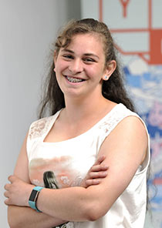  Samantha (Sam)  15 years, Rural | Sam is in Year 11 and is House Captain for her school. A young speaker for the CREATE Foundation; Sam hopes to use her position in the Victorian Youth Congress to enable change for young people who can't speak out for themselves. She will bring a strong voice and her unique outlook to the Victorian Youth Congress, to making positive change for young Victorians.
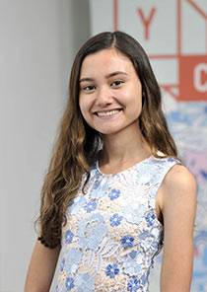  Yasmin  19 years, Metro | Yasmin is a second year Arts/Law student at Monash University. While part of the Victorian Youth Congress Yasmin wants to create a positive working relationship between the Government and young people, and to contribute to youth-led solutions to the issues affecting young Victorians. Yasmin brings her diverse experience in government and youth-led non-government-organisations, along with a passion to make a real impact on the lives of others.
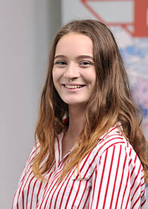  Saskia  16 years, Rural | Saskia commenced Year 12 in 2018, as a Select Entry Accelerated Learning Program student. Saskia hopes to pursue a career in law and justice. She is excited to be selected for the Victorian Youth Congress and believes it will be an incredible opportunity to help shape and empower her generation to becoming strong and inspired adults. Saskia is passionate about youth engagement and empowerment and hopes to contribute to strong, positive change.
Fereshta (Fresh)  16 years, Metro | Fresh is a Year 12 student and stands out as a passionate advocate for young people's rights, issues and interests. While a part of the Victorian Youth Congress Fresh hopes to utilise these advocacy skills to create positive change for young Victorians. A self-motivated, dedicated and active member of the community, Fresh is a member of the Youth Affairs Council of Victoria, and has played an important role in a number of key events and consultations with the organisation.
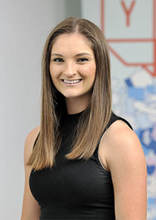  Laura  25 years, Metro | Laura works full-time at her Local Learning and Employment Network. Through her work, Laura is committed to ensuring local young people are engaged in education and are making smooth transitions into further study or employment. Laura wants to be a part of the Victorian Youth Congress to ensure young people have a say in shaping and influencing the policies that affect them. She bring to the Youth Congress her knowledge of the challenges experienced by young people in education and employment, as well as an enthusiasm to work collaboratively in order to bring about change.
Ashleigh  23 years, Metro | Ashleigh is a young consultant through the Create Foundation and sits on multiple youth advisory groups. Ashleigh wants to be on the Victorian Youth Congress to utilise her networks and give young people a voice to empower them to make change. Ashleigh will bring her leadership skills, along with her skills in organisation and conflict resolution, to the Victorian Youth Congress.

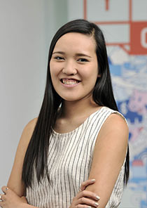  Sandra  25 years, Metro | Sandra recently graduated from RMIT University with a Master of Public Policy. Born in Singapore, she migrated to Australia when she was 11 years old. She has five years' experience in the non-profit sector, working with disadvantaged children and young people. Sandra has a passion for empowering young people and plans to use her position on the Victorian Youth Congress to help ensure that the voices of young people are heard and valued by both policymakers and the wider community.
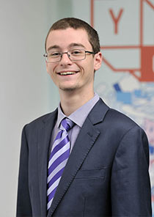  Alex  18years, Metro | Alex is a Student Nurse, Volunteer First Responder with St John Ambulance, and Diabetes Advocate. Alex thrives on supporting change and aspires to be part of history in helping to shape the future of Victoria. Alex believes in the importance of young people being involved in decision making processes, and is excited to share the Victorian Youth Congress experience with fellow Youth Congress members.
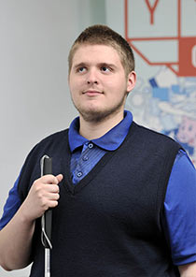  Christopher  18 years, Metro | Christopher is currently studying VCE units 1 and 2 at RMIT University, and is a member of the Youth Disability Advocacy Service. Christopher wants to improve the experiences of young people, specifically issues relating to housing, mental health, and education. He will bring his life experience of having a disability and experience of homelessness to the Victorian Youth Congress.

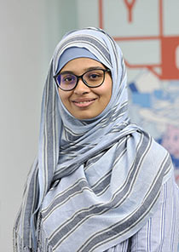  Yumna  25 years, Rural | Yumna is a young Muslim woman who lives, studies and works in regional Victoria. Yumna is passionate about young people, particularly the issues faced by those in rural areas. Yumna works casually as a youth facilitator at the Centre for Multicultural Youth and is in her second year of a Diploma of Community Services at Federation Training. Yumna wants to provide a culturally diverse and regional voice to the Victorian Youth Congress.
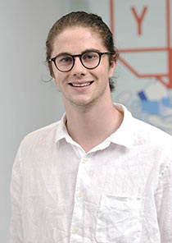  Harrison  20 years, Metro | Harrison is a third year Arts/Law student. He is eager to provide practical policy solutions on issues that affect young people, and to support the Victorian Youth Congress as a body that places young people at the forefront of policy and program design. Harrison is especially passionate about advocating on behalf of young LGBTQIA+ people across the state, and hopes to spend the year championing the voices of young people and engaging with their unique lived experiences.
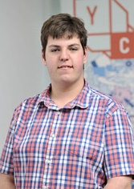  William  18 years, Rural | William is a team member at one of his local supermarkets and a radio presenter on Gippsland FM and Syn Nation for the youth affairs show, "YouthConnect". William plans to study at Federation University Gippsland in 2018, where he hopes to study a Bachelor of Criminal Justice. William is keen to represent the concerns of his region and to share his unique perspective and ideas.

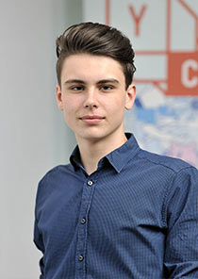  Jack N  17 years, Rural | Jack is a high school student, youth activist, and a community radio presenter. He also is actively involved in various community and not-for-profit organisations, both locally and in Melbourne. Jack has a passion for storytelling and in climate change issues, and wants to give young people in his local area a voice on a state level. He brings to the Victorian Youth Congress his these passions, along with his experiences and his drive to create meaningful change.
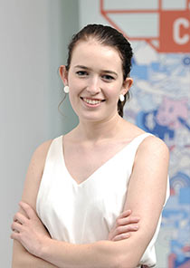  Amelia,  19 years, Rural | Amelia recently completed VCE and hopes to study an Arts/Law degree at Monash University. She sees the Victorian Youth Congress as an opportunity to improve the lives of young people in Victoria, especially for those who have a mental illness. She has a strong background in volunteering, along with a passion for helping young people in need.
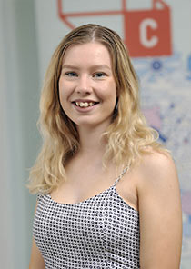  Alyssa  17 years, Metro | Alyssa is currently enrolled in VCE and is excited to be part of the Victorian Youth Congress as it gives her the opportunity to utilise her personal experiences as a student and member of the Victorian Student Representative Council (VicSRC). Alyssa was elected to the VicSRC Student Executive team in July 2017. Alyssa has a strong determination for success and resilience, regardless of the barriers or obstacles placed before her.

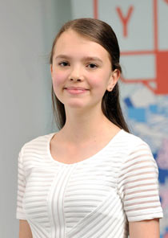  Sachi  14 years, Metro | Sachi is studying Year 9 in 2018. She is passionate about social justice and hopes to play a role in helping to prioritise, develop and implement policies that enhance the safety, connectivity and quality of life of young Victorians. Sachi will bring to the Youth Congress a love for public speaking, debating and problem solving, along with her experience in leadership roles, including School Captain, Social Justice and Student Council Representatives. Sachi also brings her background in volunteering for humanitarian organisations, such as the Rotary Club.
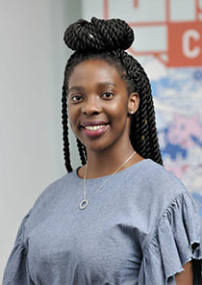  Sherry-Rose  21 years, Metro | Sherry-Rose is a young African Australian of Cameroonian descent. She is full time International Relations student, Youth Activist with Plan International, local council Youth Ambassador, former president of Afro-Australian Student Organisation and current CMY ShoutOut speaker. Sherry-Rose will share her strong sense of moral responsibility to those around her with the Victorian Youth Congress, and is eager to put herself forward to contribute to positive change.
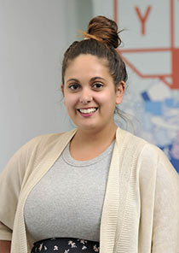  Bonnie  21 years, Metro | Bonnie is a proud Gunditjmara woman who was born and raised in Bairnsdale before moving to Melbourne's northern suburbs. Bonnie works with an Aboriginal organisation, providing family violence support across Victoria. Bonnie wants to provide the voice and perspectives of Aboriginal and Torres Strait Islander young people to the Victorian Youth Congress, as well as the lived experience of growing up in regional Victoria.

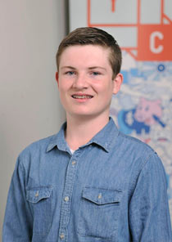  Jack W  14 years, Rural | Jack is a high school student and teenage journalist committed to speaking up for young people. He is actively involved in his local and school communities though musical theatre and news reporting, having founded his schools news station in 2017. Jack has a passion for mental health, and wants to give young people in regional Victoria a voice on a state level. He brings to the Victorian Youth Congress these passions, along with his experience in leadership, public speaking and communication.
Gemma  24 years, Metro | Gemma has served as a Youth member of the Minus18 Foundation board since February 2016. In this role, she develops strategy and oversees financial management of Australia's largest youth-led network for LGBTIQ+ young people. In addition, Gemma has had diverse legal experiences across criminal, community, commercial and refugee law. In 2013-14, Gemma served as Director of Social Justice & Equity for the Monash Law Students' Society, where she managed events, publications, equity and student advocacy projects.
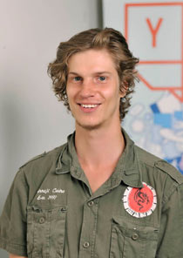  Heath  24 years, Metro | Heath is an active contributor to his community having been a member of several advisory groups. Currently a studying a Diploma in Community Services and member of the Melbourne City Mission youth alumni, Heath brings a unique experience and important perspective to the Victorian Youth Congress. Heath has contributed to improving youth homelessness in Victoria and is committed to supporting young and vulnerable people in the community.

